CAREER CRAFTER – A RESUME SCREENING WEBSITE

PROJECT REPORT

Submitted by

ROSHINI R (212CB140)
LAKSITA V S(212CB127)
AKSHAYA R(212CB103)

In partial fulfillment for the award of the degree of

BACHELOR OF TECHNOLOGY
IN
COMPUTER SCIENCE AND BUSINESS SYSTEMS

BANNARI AMMAN INSTITUTE OF TECHNOLOGY
(An Autonomous Institution Affiliated to Anna University, Chennai)

SATHYAMANGALAM-638401

ANNA UNIVERSITY: CHENNAI 600 025

NOVEMBER 2023

BONAFIDE CERTIFICATE

Certified that this project report “CAREER CRAFTER – A RESUME SCREENING WEBSITE” is the bonafide work of “ROSHINI R (212CB140), LAKSITA V S (212CB127), AKSHAYA R (212CB103)” who carried out the project work under my supervision.

SIGNATURE | SIGNATURE
Dr. PRIYA J | Dr. PRIYA J
HEAD OF THE DEPARTMENT | HEAD OF THE DEPARTMENT
Department of Computer Science and Business Systems | Department of Computer Science and Business Systems
Bannari Amman Institute of  Technology | Bannari Amman Institute of Technology
Sathyamagalam | Sathyamagalam

Submitted for Viva Voice examination held on ………………

INTERNAL EXAMINER 1 INTERNAL EXAMINER 2
ABSTRACT
Career Crafter is an innovative resume screening website that enhances the traditional job matching process by integrating a dynamic interview preparation feature. Leveraging cutting-edge technologies, the platform predicts the job fit for uploaded resumes and provides users with a tailored set of 10 interview questions specific to the predicted domain.
The key features include a domain-specific question bank that covers technical, behavioural, and situational queries, ensuring a holistic interview preparation experience. The system dynamically generates questions based on the predicted domain and the candidate's expertise level, fostering a personalized approach.
Technologically, Career Crafter employs state-of-the-art machine learning (ML) models for resume screening, utilizing natural language processing (NLP) techniques to extract relevant information. The dynamic question generation leverages AI (Artificial Intelligence) algorithms to tailor interview questions and the platform's web-based architecture ensures accessibility across devices.
Career Crafter represents a paradigm shift in the recruitment landscape, providing users with not only job predictions but also a comprehensive interview preparation tool, ultimately empowering individuals to navigate their career paths with confidence.
Keywords: Resume Screening, Job Matching, Interview Preparation, Predictive Analytics, Machine Learning, Career Empowerment.

i

TABLE OF CONTENTS

C.NO | TITLE | PAGE NO
 | ABSTRACT | i
 | LIST OF FIGURES | ii
 | LIST OF ABBREVIATIONS | iii
1 | INTRODUCTION | 1
2 | LITERATURE REVIEW  2.1 SCREENING RESUMES IN A PLATFORM  2.2 MACHINE LEARNING AND NATURAL LANGUAGE PROCESSING  2.3 REVOLUTIONIZING RECRUITMENT  2.4 COGNITIVE TRAINING REDUCES DISCRIMINATION  2.5 ADVANCEMENTS IN AUTOMATED RESUME CLASSIFICATION | 2  2  2  2  3  3
3 | PROJECT DESCRIPTION | 4
 | 3.1. PROBLEM DEFINITION | 4
 | 3.2. PROPOSED SYSTEM | 4
 | 3.2.1. STRUCTURE OF PROPOSED SYSTEM | 5
4 | SYSTEM REQUIREMENTS AND IMPLEMENTATION | 7
 | 4.1 SYSTEM REQUIREMENTS | 7
 | 4.1.1. HARDWARE REQUIREMENTS | 7
 | 4.1.2. SOFTWARE REQUIREMENTS | 7
 | 4.2. DESCRIPTION OF SOFTWARE | 8
 | 4.3. DESCRIPTION OF NLP LIBRARIES USED | 9
 | 4.4. IMPLEMENTATION AND WORKING PRINCIPLE | 12
 | 4.5. DESIGN AND IMPLEMENTATION | 14
5 | EXPERIMENTAL RESULTS | 17
 | 5.1. SCREENSHOTS | 17
6 | CONCLUSION AND FUTURE WORK | 19
 | 6.1. CONCLUSION | 19
 | 6.2. FUTURE WORK  REFERENCES | 19  20

LIST OF FIGURES

FIGURE NO | FIGURE NAME | PAGE NO
1  2 | Natural Language processing  Proposed Plan | 1  6
3 | NLTK | 7
4 | Spacy | 9
5 | Genism | 12
6 | TextBlob | 13
7 | Working Principle | 14
8 | Website Frontpage | 15
9 | Uploading the resume into the website | 15
10 | Printing the Predicted Output | 21
11 | Suggested interview Questions for the predicted result | 22

ii

LIST OF ABBREVATIONS

ACRONYM | ABBREVATION
ML | ML Machine Learning
NLTK | NLTK Natural Language ToolKit
DL | DL Deep Learning
RAM | RAM Random Access Memory
NLP | NLP Natural Language Processing
OS | OS Operating System
MVP | MVP Minimum Viable Product

iii

CHAPTER 1

INTRODUCTION
Career Crafter, an innovative project in the realm of career development, seeks to redefine the traditional resume screening process. This platform represents a significant advancement in predicting the ideal job fit for uploaded resumes. While our foundation rests on a robust existing model, we are dedicated to showcasing our commitment to innovation and excellence by introducing distinctive functionalities.
Upon uploading a resume, Career Crafter initiates a multifaceted analysis, leveraging state-of-the-art machine learning (ML) models for resume screening. Utilizing advanced natural language processing (NLP) techniques, the platform extracts relevant information to determine the most suitable job opportunities for the user.
A standout feature of Career Crafter is our dynamic interview preparation tool. When a user uploads their resume, the system dynamically generates a set of 10 interview questions specifically curated for the predicted domain. This process involves a sophisticated algorithm that analyzes the resume's content, considering the predicted domain and the candidate's expertise level. The suggestions aim to cover a spectrum of technical, behavioral, and situational queries, ensuring a comprehensive preparation experience.
Technologically, our platform utilizes artificial intelligence (AI) algorithms to dynamically generate interview questions, ensuring relevance to the predicted domain. This AI-driven approach enhances the accuracy and specificity of the suggested questions, providing users with a personalized and effective interview preparation plan.

CHAPTER 2

LITERATURE REVIEW

2.1 SCREENING RESUMES IN A PLATFORM
[1] The study by Amin, Sujit, et al. presents a web application for screening resumes. The research focuses on the development and implementation of this technology, providing a platform for automated resume screening. The study contributes to the field of recruitment technology by introducing a tool aimed at enhancing the efficiency of the resume screening process.

2.2 MACHINE LEARNING AND NATURAL LANGUAGE PROCESSING
[10] The presented article discusses the use of machine learning (ML) and natural language processing (NLP) in resume analysis for efficient recruitment. The literature review highlights various approaches such as resume parsing with NLP, recommendation systems using cosine similarity, and ML-based resume ranking systems. The proposed methodology involves NLP techniques, data extraction, ML models, and candidate feedback to enhance the hiring process, with testing demonstrating high accuracy in resume parsing and analysis.

2.3 REVOLUTIONIZING RECRUITMENT
[12] The article explores the transformative impact of machine learning (ML) and natural language processing (NLP) on Indian recruitment, emphasizing specialized agencies' use of ML models for efficient talent acquisition. The proposed model advocates for a fairer hiring process by leveraging NLP to extract pertinent information from resumes, offering accurate ratings. The suggested incorporation of personalized feedback enhances the potential of the web portal as a valuable resource for both applicants and hiring managers, fostering continuous improvement in the recruitment landscape.

2.4 COGNITIVE TRAINING REDUCES DISCRIMINATION
[6] The study explores reducing hiring discrimination in resume-screening through cognitive training interventions. Initial biases against ethnic minority applicants decreased shortly after culture-general assimilator and structured free recall interventions. However, hiring discrimination resurfaced three months later, highlighting the complexity of prejudice reduction initiatives and the need for further research on sustained impact.

2.5 ADVANCEMENTS IN AUTOMATED RESUME CLASSIFICATION
[15] The study by Roy et al. (2022) contributes to the field of automated resume classification using machine learning. The authors address the growing importance of efficient resume screening in the recruitment process. They likely build upon existing research on natural language processing, machine learning, and text classification techniques. This work aims to enhance the automation of resume evaluation, potentially improving the accuracy and speed of candidate selection.

CHAPTER 3

3. PROJECT DESCRIPTION
The objective is to streamline the resume review process to enhance efficiency in hiring. This involves the automation of initial resume evaluations to assist recruiters, ultimately speeding up the review process and enabling the handling of high volumes of resumes. The implementation of automation aims to provide data insights through the collection and analysis of relevant information, facilitating informed hiring decisions.

PROBLEM DEFINITION
In today's highly competitive job market, individuals frequently encounter difficulties aligning their unique skills and experiences with appropriate job opportunities. The complexity of identifying positions that resonate with their qualifications often results in a mismatch between job seekers and suitable roles. Moreover, the lack of tailored interview preparation exacerbates the challenge, leaving candidates unprepared for job-specific interviews. This unmet need underscores the importance of a comprehensive solution that not only streamlines the job matching process but also addresses the crucial aspect of interview readiness, ensuring individuals are well-equipped to showcase their capabilities and secure positions in their desired job domains.

PROPOSED SYSTEM
Career Crafter addresses these challenges by utilizing resume screening to predict job fits based on individual qualifications. To enhance its innovative approach, the platform goes beyond mere predictions and tackles interview unpreparedness by suggesting 10 tailored interview questions specific to the predicted job domain. This dual solution not only streamlines the job matching process but also empowers users with targeted interview preparation, bridging the gap between resume screening and successful interview performance.

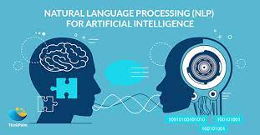
Fig.3.1. Natural Language Processing

Structure of proposed system

User Interface (UI): Career Crafter features an intuitive and visually appealing user interface that facilitates seamless navigation. The UI is designed to be user-friendly for both job applicants and recruiters, providing a positive experience throughout the resume screening process.

Resume Parsing Engine: At the core of Career Crafter is a powerful resume parsing engine. This engine utilizes advanced natural language processing (NLP) techniques to extract relevant information from resumes, including skills, experience, and qualifications. This ensures accurate data extraction for thorough resume analysis.

Machine Learning Algorithms: Career Crafter incorporates machine learning algorithms to evaluate and score resumes based on predefined criteria. These algorithms learn from historical data to make informed decisions, enabling the app to rank resumes according to their relevance to specific job profiles.

Feedback and Improvement Module: Career Crafter goes beyond mere screening by incorporating a feedback and improvement module. This feature allows the app to provide personalized feedback to job applicants, helping them understand areas for improvement in their resumes. This iterative feedback loop enhances the overall quality of resumes submitted.

Security Measures: Given the sensitivity of personal information in resumes, Career Crafter implements stringent security measures. The app follows industry best practices to protect user data, ensuring confidentiality and compliance with data protection regulations.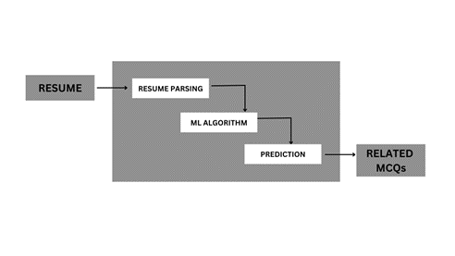

Fig.3.2. Proposed Plan

CHAPTER 4

4. SYSTEM REQUIREMENTS ANDIMPLEMENTATION

4.1 REQUIREMENTS
4.1.1 HARDWARE REQUIREMENT

Processor: Dual-core processor or higher

RAM: 4 GB or more

Storage: 20 GB free disk space

Internet Connectivity: Broadband connection for seamless data processing

4.1.2 SOFTWARE REQUIREMENT

Operating System: Windows 10 or macOS

Web Browser: Latest versions of Chrome, Firefox, or Safari

Database: MySQL for data storage

Programming Languages: Python for backend development

Frameworks: Streamlit for web application development

Additional: NLP libraries for resume parsing and analysis

  - DESCRIPTION OF THE SOFTWARE

Operating System (OS): Windows 10 or macOS:

Career Crafter ensures broad accessibility by supporting two widely used operating systems—Windows 10 and macOS. This allows users on both platforms to seamlessly engage with the resume screening website, promoting inclusivity.

Web Browser: Latest versions of Chrome, Firefox, or Safari

The project prioritizes compatibility by catering to popular web browsers such as Chrome, Firefox, and Safari. This ensures an optimal user experience, leveraging the latest features and security enhancements provided by these widely adopted browsers.

Database: MySQL for Data Storage

MySQL serves as the robust data storage backbone for Career Crafter. Its relational database management system facilitates efficient and structured storage of user data, ensuring scalability and reliability for the resume screening website.

Programming Languages: Python for Backend Development

Python is the chosen programming language for Career Crafter's backend development. Renowned for its readability and versatility, Python enables the creation of a powerful and flexible backend infrastructure, facilitating smooth functionality and data processing.

Frameworks: Streamlit for Web Application Development

Leveraging the Streamlit framework for web application development, Career Crafter benefits from a high-level, Python-based framework. Streamlit streamlines the development process, offering built-in features for security, scalability, and rapid deployment, contributing to the efficiency of the resume screening website.

Additional: NLP Libraries for Resume Parsing and Analysis

Career Crafter integrates Natural Language Processing (NLP) libraries to enhance its resume parsing and analysis capabilities. These libraries enable the extraction of valuable information from resumes, ensuring accurate predictions and personalized functionalities for users, making the resume screening process more effective and dynamic.

4.3. DESCRIPTION OF NLP LIBRARIES USED:

NLTK (Natural Language Toolkit):

Description: NLTK is a comprehensive library for natural language processing in Python. It provides tools for tasks such as tokenization, stemming, tagging, parsing, and semantic reasoning.

Project Integration: NLTK can be utilized for tokenization part-of-speech tagging, enhancing the system's ability to extract relevant information from resumes.

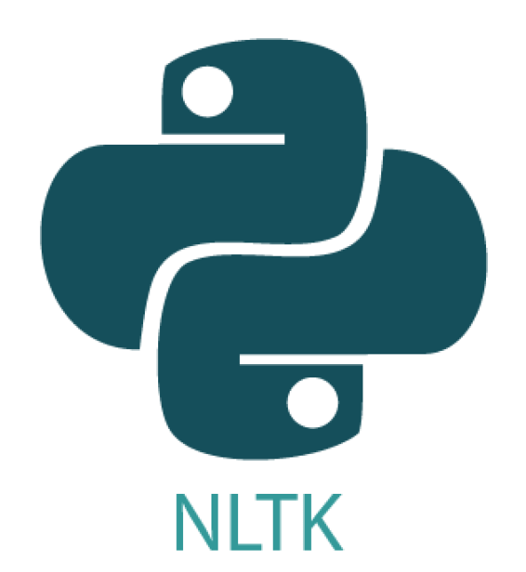

Fig.2. NLTK

Spacy:

Description: Spacy is an advanced NLP library that offers pre-trained models for various languages. It excels in entity recognition, dependency parsing, and other linguistic annotations.

Project Integration: Spacy's entity recognition capabilities can be valuable for extracting specific entities like skills, experiences, and qualifications from resumes.



Fig.3. Spacy

Gensim:

Description: Gensim is a library for topic modeling and document similarity analysis. It is particularly useful for extracting themes and patterns from large text corpora.

Project Integration: Gensim can aid in identifying key themes and similarities in resumes, contributing to a more nuanced understanding of candidates' qualifications.



Fig.4. Genism

TextBlob:

Description: TextBlob is a simplified NLP library that is easy to use for common NLP tasks such as part-of-speech tagging, noun phrase extraction, and sentiment analysis.

Project Integration: TextBlob can be employed for sentiment analysis of text in resumes, providing insights into the overall tone of candidate profiles.

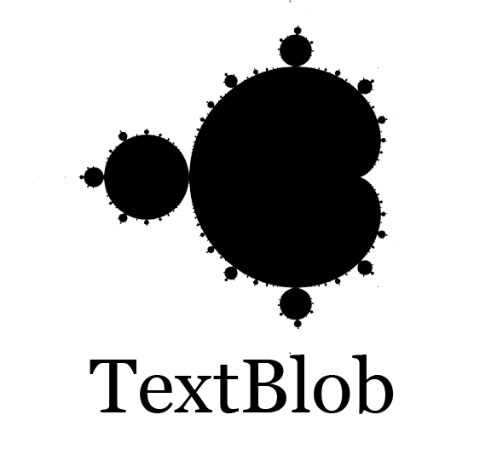

Fig.5. TextBlob

Pyresparser:

Description: Pyresparser is a Python library specifically designed for parsing resumes. It uses NLP techniques and machine learning algorithms to extract key data points from resumes.

Project Integration: Pyresparser can be seamlessly integrated into the system for efficient resume parsing, extracting essential information like contact details, work experience, and skills.

4.4 IMPLEMENTATION AND WORKING PRINCIPLE
- Job Prediction:
On the Career Crafter platform, users initiate their journey by uploading their resumes. The system, equipped with advanced predictive algorithms, meticulously analyzes these resumes, discerning the intricate details of users' skills and experiences. Leveraging this comprehensive understanding, the platform then engages in the task of predicting the most fitting job opportunities for each user. This innovative approach streamlines the job search process, offering tailored suggestions that align with individuals' unique professional backgrounds and capabilities.
- Interview Preparation:
Following the insightful job predictions, Career Crafter takes another proactive step by dynamically generating 10 interview questions that are specifically tailored to the predicted job domain. This feature empowers users with a targeted and practical tool for interview preparation. By providing a set of relevant questions reflective of the anticipated job role, the platform enables users to review and strategically prepare for upcoming interviews. This not only enhances their overall readiness but also equips them with the confidence to navigate job-specific inquiries, ultimately optimizing their chances of success in the competitive job market. Skill Mastery Recommendations:
- Current Job Trends:
Career Crafter not only predicts suitable jobs and tailors interview questions but also provides users with insights into current trends in the predicted job domain. Users gain valuable information on emerging skills and industry dynamics, ensuring they stay well-informed about the evolving job landscape. This feature enhances users' overall awareness and adaptability in the competitive job market.
- Trending Jobs Display:
Career Crafter presents real-time trending jobs based on user preferences, empowering them to make informed decisions in line with current market demands.
- User Interaction:
The platform encourages user engagement to navigate through job predictions, interview questions, skill recommendations, and trending job displays.
- Iterative Process:
Users can iteratively use Career Crafter as they enhance their skills and gain new experiences. The platform adapts to users' evolving profiles, offering continuous support in their career journeys.
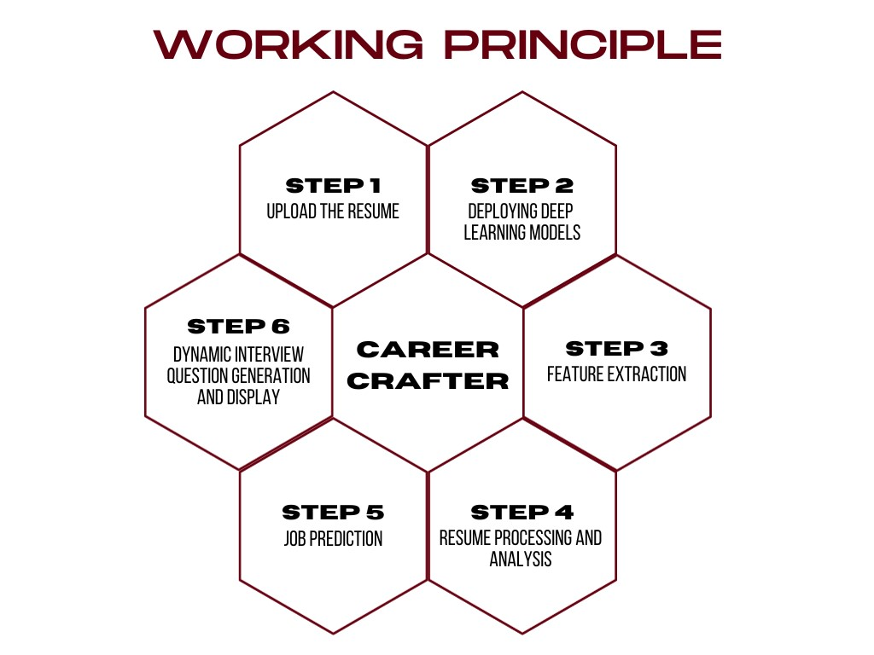
Fig.6. Working Principle

4.5 DESIGN & IMPLEMENTATION
Designing and implementing Career Crafter involves a systematic approach to each specified requirement. A detailed description of implementation is given below.
- Operating System (Windows 10 or macOS):
- Design Approach: Utilize cross-platform development tools and frameworks to ensure compatibility with both Windows 10 and macOS.
- Implementation Steps: Choose a development framework that supports cross-platform deployment. Test the application on both Windows and macOS environments to identify and resolve any compatibility issues.

- Web Browser (Chrome, Firefox, Safari):
- Design Approach: Optimize the website for popular web browsers like Chrome, Firefox and Safari to ensure a consistent user experience.
- Implementation Steps: Conduct cross-browser testing to ensure compatibility. Address any rendering or functionality issues specific to each browser.
- Database (MySQL for data storage):
- Design Approach: Design a robust database schema to accommodate user profiles, resumes, job predictions, and other relevant data.
- Implementation Steps: Set up and configure a MySQL database. Implement data models and relationships within the database. Implement secure data storage and retrieval mechanisms.
- Programming Languages (Python for backend development):
- Design Approach: Leverage Python for its readability and versatility in backend development.
- Implementation Steps: Set up a backend development environment using Python. Develop algorithms, predictive models, and business logic in Python.
- Frameworks (Streamlit for web application development):
- Design Approach: Use Streamlit for its rapid development, security features, and scalability.
- Implementation Steps: Install and configure Streamlit for the project. Develop views, templates, and integrate Streamlit 's authentication system for user management.
- Additional (NLP libraries for resume parsing and analysis):
- Design Approach: Integrate NLP libraries to enhance resume parsing and analysis for accurate predictions.
- Implementation Steps: Choose and integrate NLP libraries suitable for resume processing. Develop algorithms to extract relevant information from resumes.
- User Interface Design:
- Design Approach: Follow UX principles for an intuitive and engaging interface.
- Implementation Steps: Design wireframes and mockups for the user interface. Develop responsive and visually appealing front-end components.
- Iterative Development Approach:
- Design Approach: Develop features incrementally to facilitate continuous user feedback and improvements.
- Implementation Steps: Release minimum viable products (MVPs) and gather user feedback. Incorporate feedback into subsequent iterations, improving features and addressing user needs.

CHAPTER 5

5. EXPERIMENTAL RESULT

5.1 SCREENSHOTS

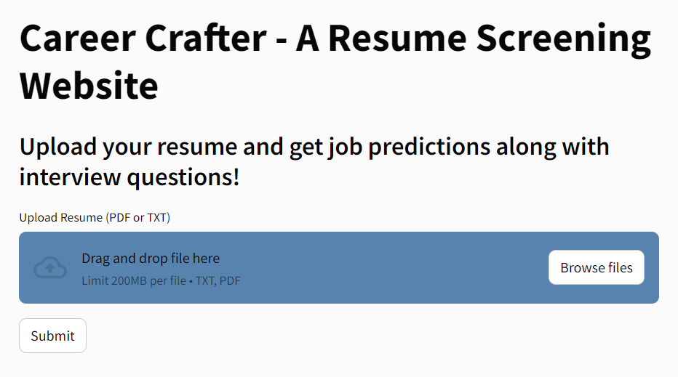

Fig.7. Website frontpage

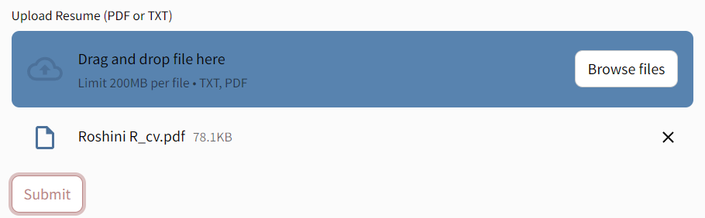
Fig.8. Uploading the resume into the website\

Fig.9. Printing the predicted result

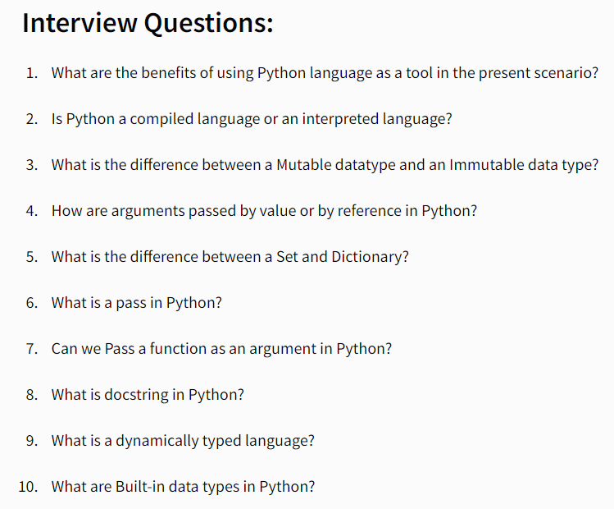
Fig. 5.10. Suggested interview question for the predicted result

CHAPTER 6

CONCLUSION AND FUTURE WORK

6.1 CONCLUSION
Career Crafter not only redefines the job-seeking experience but also seamlessly integrates with trending technologies like AI. Its user-friendly interface caters to a broad audience, offering predictive job roles, tailored interview preparation, and skill recommendations. The platform's ease of implementation, coupled with its alignment with cutting-edge technologies, positions Career Crafter as a valuable asset for both job seekers and employers. With its adaptability and relevance in the rapidly evolving job market, Career Crafter is poised to be a significant player in the intersection of technology and career advancement.

6.2 FUTURE WORK
The future work of Career Crafter involves continuous enhancement and adaptation to meet evolving job market dynamics and converting this into a mobile application for HRs. This includes refining predictive algorithms for more accurate job role predictions, expanding the database for a wider range of interview questions, and incorporating real-time updates on emerging job trends. Collaborations with industry experts like HRs and job recruiters as well as employers could further enrich the system, ensuring it remains at the forefront of innovation in career development. Ongoing research and development efforts will aim to solidify Career Crafter as a dynamic and indispensable tool for individuals navigating the ever-changing landscape of the professional world.

REFERENCE

[1] Amin, Sujit, et al. "Web application for screening resume." 2019 International Conference on Nascent Technologies in Engineering (ICNTE). IEEE, 2019.
[2] Daryani, Chirag, et al. "An automated resume screening system using natural language processing and similarity." ETHICS AND INFORMATION TECHNOLOGY [Internet]. VOLKSON PRESS (2020): 99-103.
[3] Singh, Amit, et al. "PROSPECT: a system for screening candidates for recruitment." Proceedings of the 19th ACM international conference on Information and knowledge management. 2010.
[4] Tijare, Poonam, et al. "A smart resume screening tool for customized shortlisting." ITM Web of Conferences. Vol. 56. EDP Sciences, 2023.
[5] Furtmueller, Elfi, Celeste Wilderom, and Mary Tate. "Managing recruitment and selection in the digital age: e-HRM and resumes." Human Systems Management 30.4 (2011): 243-259.
[6] Derous, Eva, Hannah-Hanh D. Nguyen, and Ann Marie Ryan. "Reducing ethnic discrimination in resume-screening: a test of two training interventions." European Journal of Work and Organizational Psychology 30.2 (2021): 225-239.
[7] Sronce, Cara R. "The references of the twenty-first century: Regulating employers' use of social networking sites as an applicant screening tool." S. Ill. ULJ 35 (2010): 499.
[8] Harrison, Janelle L. Employer and recruiter use of social networking websites as a candidate screening tool. Gonzaga University, 2008.
[9] Arora, Sunaina, and Neeraj Kumari. "Recruitment search engines for screening resumes through AI by using boolean search functions." Journal of Asian Development 7.2 (2021): 16-26.
[10] Jivtode, Alkeshwar, Kisan Jadhav, and Dipali Kandhare. "RESUME ANALYSIS USING MACHINE LEARNING AND NATURAL LANGUAGE PROCESSING."
[11] Chen, Dan. Artificial Intelligence (AI) in Employee Selection: How Algorithm-Based Decision Aids Influence Recruiters’ Decision-Making in Resume Screening. Diss. The University of Texas at Arlington, 2022.
[12] Roy, Pradeep Kumar, Sarabjeet Singh Chowdhary, and Rocky Bhatia. "A Machine Learning approach for automation of Resume Recommendation system." Procedia Computer Science 167 (2020): 2318-2327.
[13] Jagtap, V. G., et al. "RESUME SCREENING AND COURSE RECOMMDATION SYSTEM."
[14] Kinge, Bhushan, et al. "Resume screening using machine learning and NLP: A proposed system." International Journal of Scientific Research in Computer Science, Engineering and Information Technology 8.2 (2022): 253-258.
[15] Roy, Pradeep Kumar, et al. "Automated Resume Classification Using Machine Learning." Advances in Distributed Computing and Machine Learning: Proceedings of ICADCML 2022. Singapore: Springer Nature Singapore, 2022. 307-316.

